**DevOps Assignment**

**1)Describe the usage of the git stash command by using an example and also state the process by giving the screenshot of all the commands written in git bash.**

**Git stash command:**

* Git stash command enables us to switch branches without committing the current branch.
* Git temporarily saves data safely without committing.
* Saves the uncommitted changes for the later use.
* Stash will move your modified files into a stack.
* Stashing takes the messy state of your working directory, and temporarily save it for further use.

First of all check the status using **git status** command

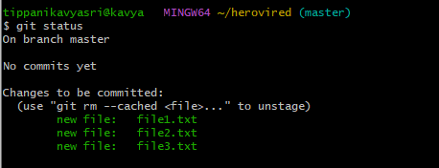

Now commit the created files using **git commit –m “message”**

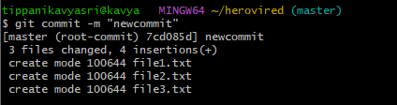

After that edit any of the files and add them and using stash push them with a message

Now again add few more lines in the file and again add it.now add the lines in the one file and push it then after listing them the pushed messages will appear we will also use some commands in git stash like

**->git stash push –m “message”**

**->git stash pop**

**->git stash drop**

**->git stash clear**

**->git stash apply <stash id>**

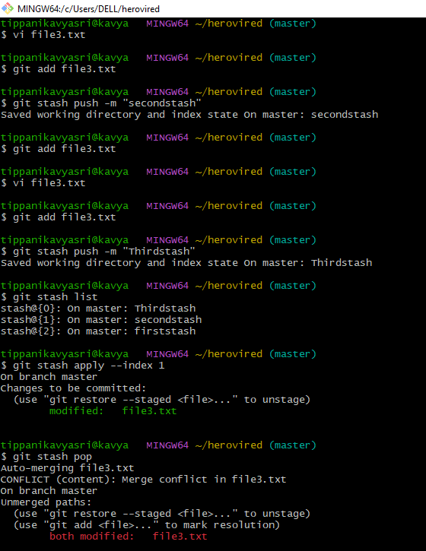

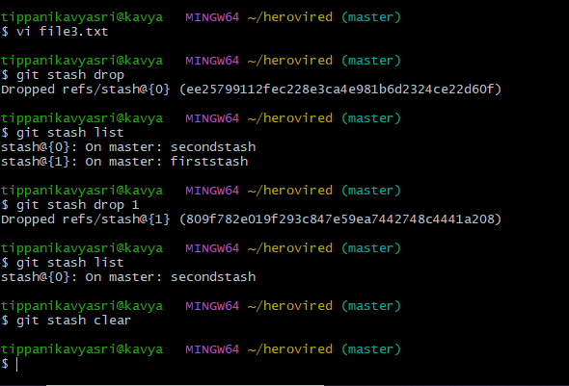

**2) By using a sample example of your choice, use the git fetch command and also use the git merge command and describe the whole process through a screenshot with all the commands and their output in git bash**

**GIT FETCH:**

The "**git fetch**"  command is used to pull the updates from remote-tracking branches. Additionally, we can get the updates that have been pushed to our remote branches to our local machines.

Used to download the contents from the remote repository, We can fetch a specific branch from a repository. It will only access the element from a specific branch.

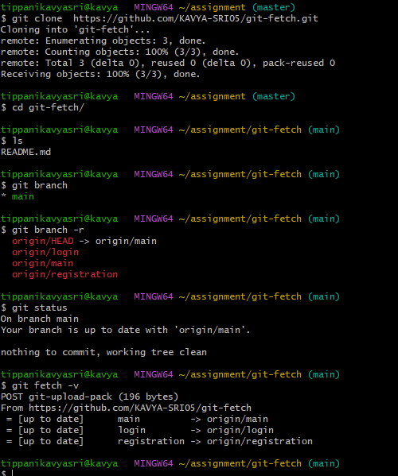

And also we can do in another manner as below

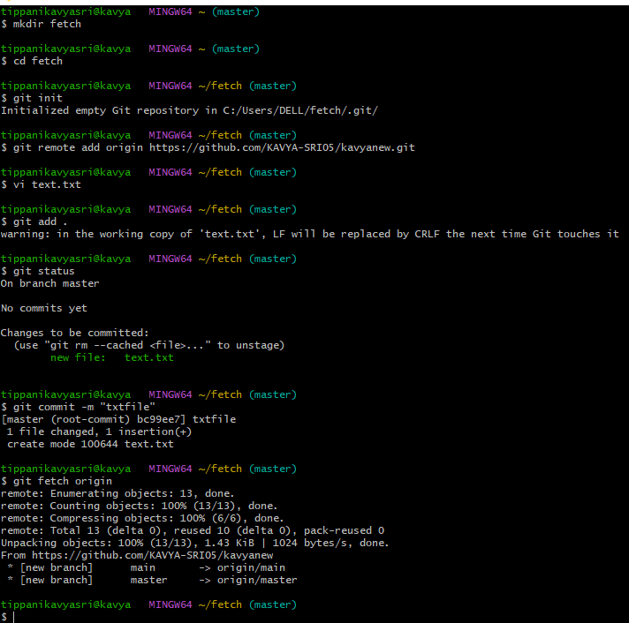

GIT MERGE:

The git merge command is used to merge the branches.Git merge will combine multiple sequences of commits into one unified history. In the most frequent use cases, git merge is used to combine two branches.

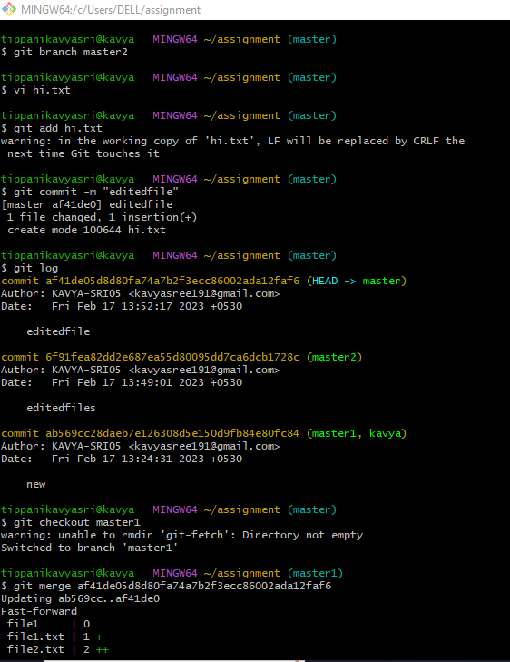

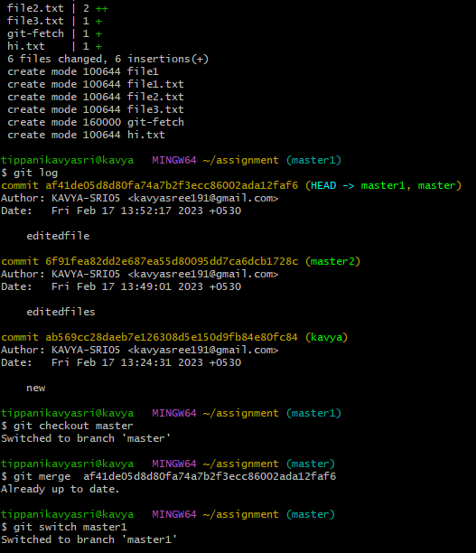

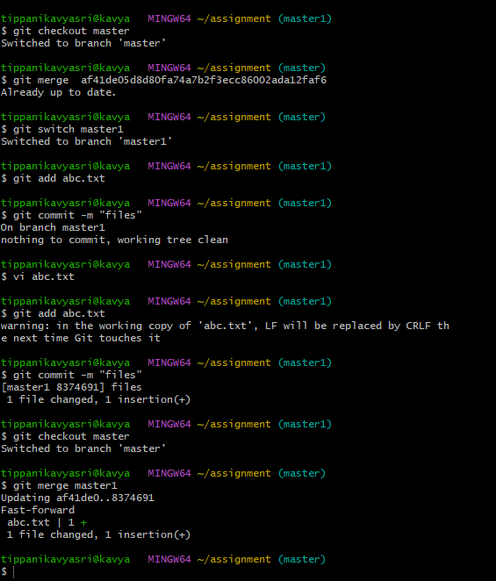

**Q3. State the difference between git fetch and git pull by doing a practical example in your git bash and attach a screenshot of all the processes**

**Git fetch:**

The "**git fetch**"  command is used to pull the updates from remote-tracking branches. Additionally, we can get the updates that have been pushed to our remote branches to our local machines.

Used to download the contents from the remote repository, We can fetch a specific branch from a repository. It will only access the element from a specific branch.



**Git pull:**

Git pull command is used to download git repository changes from a remote repository and merge those changes into our local repository.

Git pull is useful when you want to update your repository with the changes made in the remote repository. It allows you to bring in changes other individuals committed to your repository which eventually syncs in with other repositories with the changes you have committed. The git pull command first runs git fetch which downloads content from the specified remote repository. Then a git merge is executed to merge the remote content refs and heads into a new local merge commit.

Git pull=git fetch + git merge

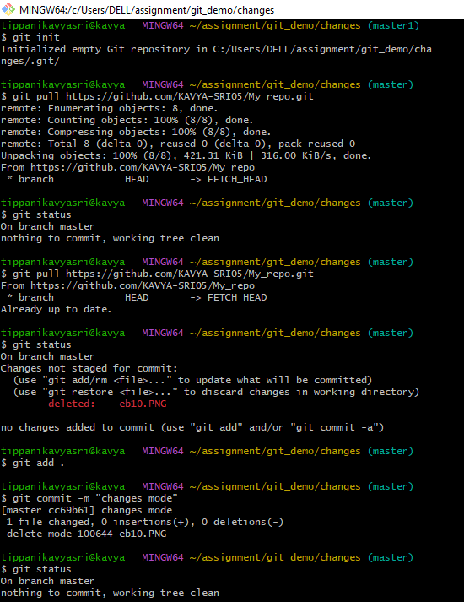

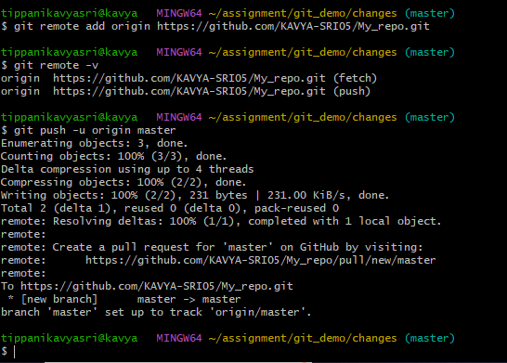

**4) Try to find out about the awk command and use it while reading a file created by yourself. Also, make a bash script file and try to find out the prime number from the range 1 to 20.**

**AWK COMMAND:**

he awk command is used for text processing in Linux.The Awk is a powerful scripting language used for text scripting. awk command searches files for text containing a pattern. When a line or text matches, awk performs a specific action on that line/text. The Program statement tells awk what operation to do; Program statement consists of a series of "rules" where each rule specifies one pattern to search for, and one action to perform when a particular pattern is found.

First of all create the file using cat and then use the awk command in the git bash to print the content in the file and then .now create a file using vi editor and then write the program of prime numbers in the script language and then we will see the output.

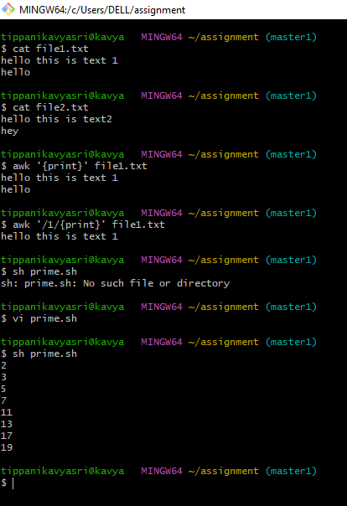

The program written in the prime.sh is shown below

.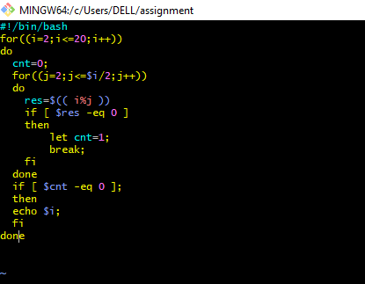

**5) Set up a container and run a Ubuntu operating system. For this purpose, you can make use of the docker hub and run the container in interactive mode**



